Richmond_Al P. Broqueza 08/30/24

IDB2 DSALGO1

Exercise 1  
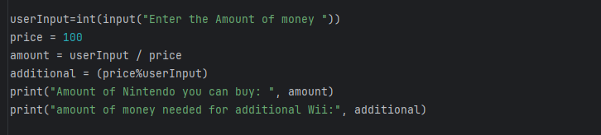

OUTPUT

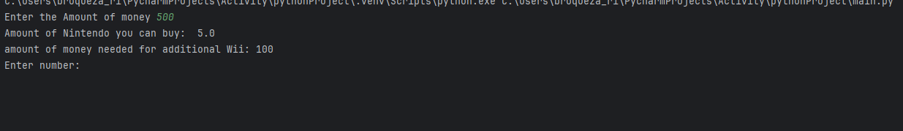

Exercise 2

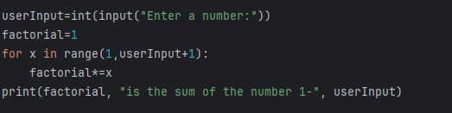

OUTPUT

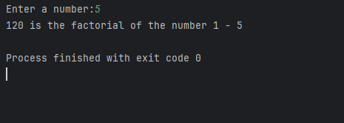

Exercise 3

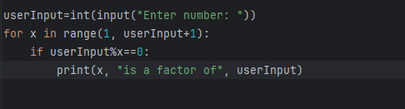

OUTPUT

